**Introduction:**

We got provided a link and we were asked if we can implement a method called p*rocess_comments.* The purpose of this method is to traverse the replies tree of a given submission,and return three lists: *negative_comments_list*, *neutral_comments_list* and *positive_comments_list*. In other words, you need to traverse all of the replies in the submission, which are structured in a tree-like format. You think this is a perfect opportunity to show off my **recursion** skills!

**Proposed solution design and implementation:**

In order of finishing this method firs of all I got to create a reddit account, at the same time I got to implement to packages for python that are import praw and import nltk, after doing that I asked my professor in order of knowing how can I transverse and move into another comments and after discussing for 20 minutes I learn how to to me into the tree, then I did my code.

For doing my method I passed 4 parameters (neg, pos, neu, and comments) the first three of them are empty lists and the last one is the URL comments code.

I got to stored the parameters of positive , neutral, negative methods and check if they are inside the comments using.body in order of comparing them later, I used a for each loop and compare if the positive parameter is bigger than the other two, then if neutral one is bigger, and neutral is bigger; if the parameter completes its statement I appended on the list that supposed to go, than finally I did a recursive method in order of connecting to the replies, and the for loop is for the comments. I didn’t do a base case because when there are not comments anymore the method should stop.

**Experimental results:**

I received a problem at first because I didn’t install properly the packages and tried by checking on starckoverflow how to fixed it, 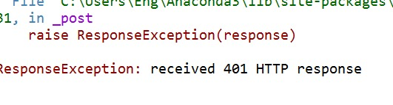

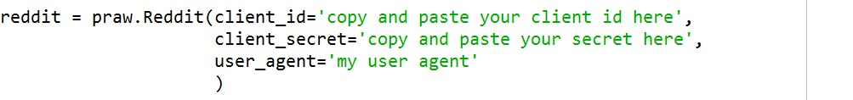

Then I didn’t know how to transverse into the method so I did firstly a base recursive method, then asked my professor if I was on the right way.

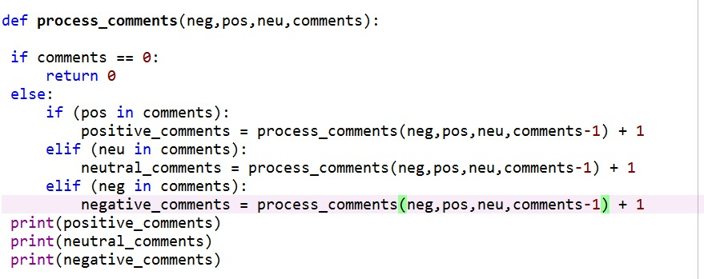

After receiving help, I finished my lab, however I got stocked in the same comment so I sent an e-mail to my T.A. in order of helping me out.

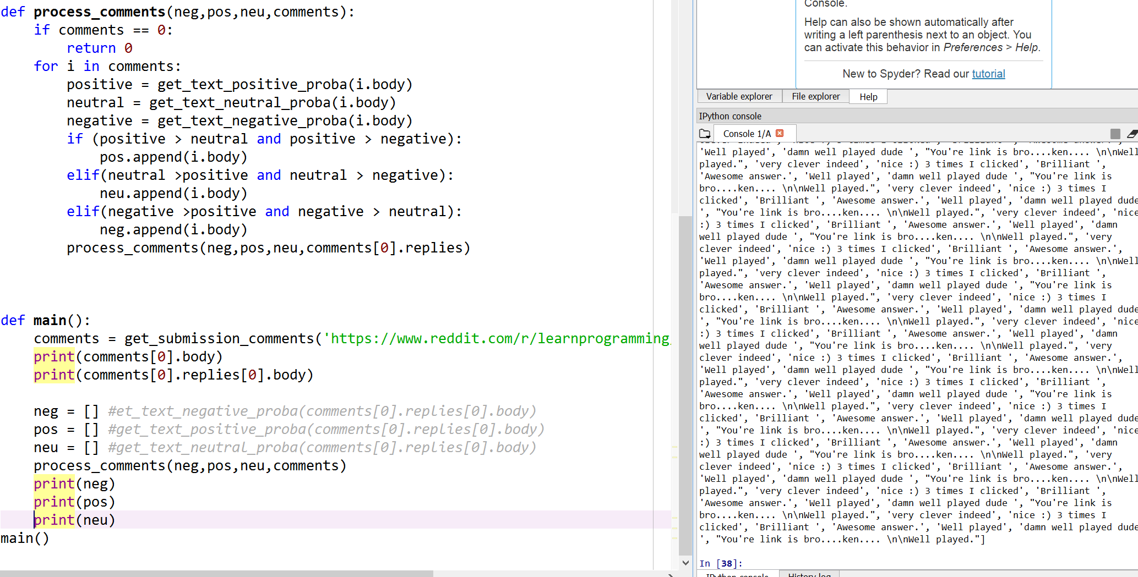

Finally, I went to my solution because I was traversing into the same line of comment and instead of using comments[0].replies I changed to i.replies and it worked.

**Conclusion:**

I felt really confident at the time finishing my lab because I never taught that I could transverse recursively into a reddit URL, the best lab I have ever done.

**Source Code:** method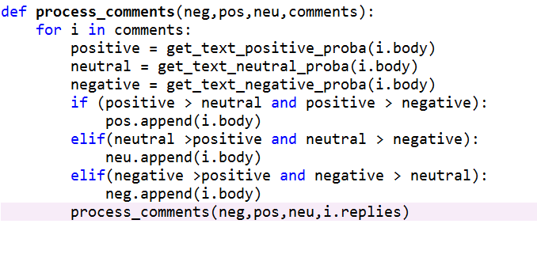

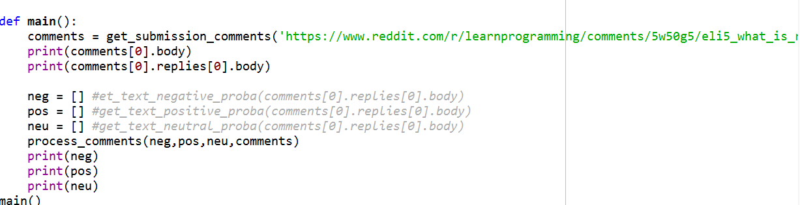

Main

**Academic Honesty**

“I certify that this project is entirely my own work. I wrote, debugged, and tested the code being presented, performed the experiments, and wrote the report. I also certify that I did not share my code or report or provided inappropriate assistance to any student in the class.”